Noakhali Science and Technology University

Department of Information and Communication Engineering

**DIGITAL IMAGE**

**PROCESSING**

**LAB MANUAL 5**

Morphological Image Processing

Prepared By: Md. Sabbir Ejaz

Lecturer, Dept. of ICE

Noakhali Science and Technology University

Department of Information and Communication Engineering

**Lab Objectives:**

The objective of this lab is to understand:

1. Dilation
2. Erosion
3. Opening
4. Closing

**Morphological Processing:**

In morphological processing of images, pixels are added or removed from the images. The structure and shape of the objects are analyzed so that they can be identified. The basic operations in this processing are binary convolution and correlation, that is based on logical operations rather than arithmetic operations. Dilation and erosion are the basic operations, and rest of the operations and algorithms are based on these operations. Morphological operations apply a structuring element to an input image, creating an output image of the same size. Dilation adds pixels to the boundaries of objects in an image, while erosion removes pixels on object boundaries. The number of pixels added or removed from the objects in an image depends on the size and shape of the structuring element used to process the image.

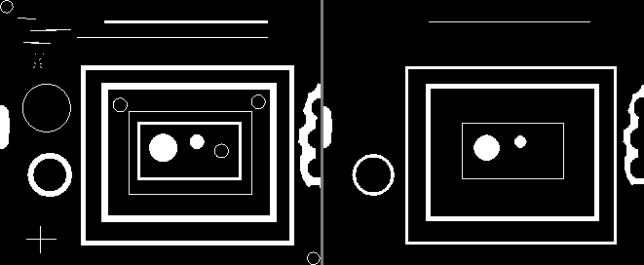

(a) Original image (b) Dilated Image (c) Eroded Image

**Practice Tasks:**

**TASK 1**

Write a program to implement dilation and note the effect on binary images.

**TASK 2**

Write a program to implement erosion and note the effect on binary images

**TASK 3**

Write a program to implement opening and note the effect on binary images



**TASK 4**

Write a program to implement closing and note the effect on binary images

